SSP Global Pop and Human Capital Projections Update (WIC2023)
This working paper documents the comprehensive update of the population and human capital projection component of the Shared Socioeconomic Pathways (SSPs), known as the Wittgenstein Centre (WIC) population projections version 3.0 (WIC2023). These projections represent the 'human core' of the SSPs and are widely utilized within the environmental and climate change research communities, particularly those associated with the Intergovernmental Panel on Climate Change (IPCC).
The updated projections use 2020 as the reference year, covering 200 countries. The methodology employed has undergone significant revisions compared to previous versions (WIC2013 and WIC2018). Notable methodological advancements include updates to education-specific fertility rates and making education differentials in mortality country- and region-specific. Crucially, the WIC2023 version introduces explicit education-specific migration differentials for the first time.
Compared to earlier projections, the WIC2023 SSP2 (Middle-of-the-Road) scenario projects a higher world population trajectory. Under SSP2, the global population is projected to peak in 2080 at 10.13 billion and decline slowly thereafter, reaching 9.88 billion by 2100. This upward revision is primarily driven by a faster expected decline in child mortality and a slower demographic transition in many low-income countries, especially in sub-Saharan Africa.
The five SSPs collectively cover a broad range of future demographic possibilities. At one extreme, SSP3 (Fragmentation/Stalled Development) leads to unabated population growth reaching 14.5 billion people by 2100. At the other end, SSP1 (Sustainability/Rapid Social Development) sees the global population peak earlier, around 2050 (below 8.5 billion), and decline to 7.4 billion by the end of the century.

Overview of the Shared Socioeconomic Pathways (SSPs)
The SSPs describe five distinct socioeconomic future worlds to 2100. The specific demographic assumptions (fertility, mortality, migration, and human capital/education) define the "human core" of each pathway.
The assumptions listed in the table below distinguish between High-Fertility Countries (HiFert) and Low-Fertility Countries (LoFert).
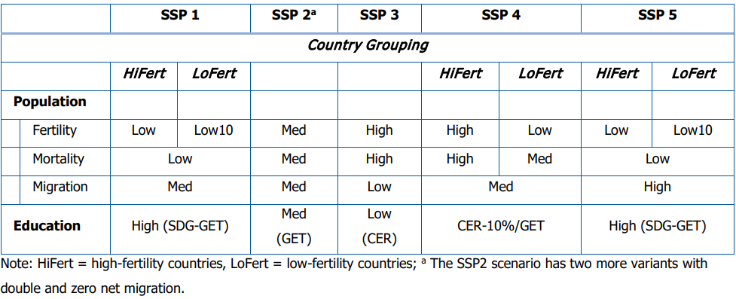

Description of the Scenarios
For Fertility, Mortality, and Migration three different levels for each process. The additional subdivision of Low10 for low fertility countries (used in SSP1 and SSP5) assumes education-specific Total Fertility Rates (TFRs) are 10% lower than medium from 2040, as opposed to 20% lower in the low case (and 20% higher in the high variant)
On education the below describes the different scenarios:
• GET (Global Education Trend - moderate path for educational development)
◦ Assumes an average trend based on the historical experience of all countries.
◦ The GET scenario is integrated into SSP2 (the Middle-of-the-Road scenario).
• CER (Constant Enrolment Rate)
◦ The CER scenario assumes that the Educational Attainment Progression Ratios (EAPRs) calculated at each level and for each country are set to be constant for the entire projection period at the level estimated for 2020.
◦ This path implies that the progression ratios for younger generations remain constant.
◦ This scenario is associated with the Low education assumption and is implemented in SSP3 (Fragmentation/Stalled Development).
• SDG-GET (Sustainable Development Goal – Global Education Trend)
◦ The SDG-GET scenario is calculated as the average of the GET and the SDG education scenarios.
◦ The underlying SDG scenario targets high-quality universal primary and secondary education by 2030.
◦ By averaging the assumptions, SDG-GET allows for fast educational development without reaching the extreme of imagining that all countries would achieve the ambitious SDG 4 target.
◦ This scenario represents the High education assumption and is implemented in SSP1 and SSP5.
• CER-10%/GET
◦ This scenario is implemented in SSP4 (Inequality) to reflect the existence of a dual society with an educated elite and a large segment of the population with lower education.
◦ It is calculated as a combination of two different progression assumptions:
1. GET (Global Education Trend) is used for the transitions to upper-secondary and post-secondary education (higher levels).
2. CER-10% is used for the transitions to other, lower levels of education. The CER-10% means that the progression transitions of the CER (SSP3) scenario are decreased by 10% for levels up to lower secondary education.

General narrative of the scenarios
• SSP1 (Sustainability): The demographic brakes and accelerator are both pressed quickly, leading to efficient, sustainable population leveling.
• SSP2 (Middle Road): The engine operates steadily at historical speeds, maintaining a moderate course.
• SSP3 (Fragmentation): The demographic accelerator is floored, the educational transmission slips badly, and population grows rapidly without sufficient human capital investment.
• SSP4 (Inequality): The engine is highly bifurcated: one small segment is equipped with a modern, high-speed transmission (high education), while the larger segment struggles with inefficient, old parts (low education), fueling large, unequal growth.
• SSP5 (Conventional): The demographic brakes are applied effectively (low fertility/mortality), but migration is maximized, driving fast economic output even if resource consumption is high.

